Council on Ministries Agenda for Tuesday, June 16, 6:00-8:00 pm
Before you arrive:
- Read through the agenda and attached material.
- Print off or have available all the documents

6.00 Prayer (Ryan)

6:01 - Mission, Vision, Motto, and Core Values (Ryan)
The mission of St James United Methodist Church is "to make disciples of Jesus Christ for the transformation of the world." (This is God's purpose for our church.)
The vision of our church is "a community of hope for every generation." (This is the picture of how our church looks as we faithfully follow God's lead.)
Our plan to be a community of hope is “go in service, grow in discipleship, and gather in celebration.” (The motto represents the foundation of the plan to get us to the picture--the Vision.)
And we are guided by our core values: acceptance, faith, family, and praise. (These set the tone of our time together.)

6:05 – Mission and Vision Celebrations (Ryan)
Doris - Nepal connection
Sharon - Arts camp and seeing the kids light up
Yev
When and where do you see God at work in and through the people of St James as we make disciples, transform, and live as a community of hope for every generation?

6:15 – Coordination and Communication of Ministry
- Feedback from P-Free Event:
  - What went well?
  - What did we learn?
  - What do we do differently next time?
- Which ministries could we highlight over the next few months? Ministry highlights are presented in worship, and, ideally, we get it on video to put online. Ministry highlights are different than announcements, but they’re ways we celebrate what God is doing as we are a community of hope for every generation.
  - June
    - 1.
  - July
    - 1.
    - 2.
  - August
    - 1.
    - 2.
  - September
    - 1.
    - 2.
- Church-Size Dynamics
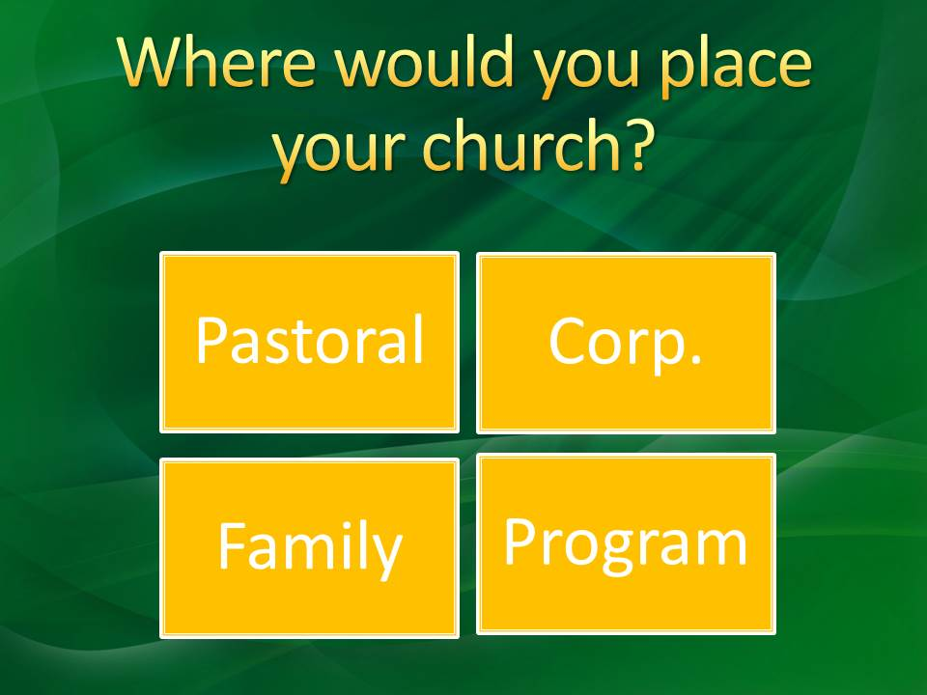

7:10 – Questions/Comments to Ryan regarding SB ministries (Mission/Vision, Policies, Administration, Staffing, etc)
Credit Card – SB approved a credit card policy to be used by pastor and Mary Ott. I think if this goes well, it can then be expanded beyond them.
7:20 – Conclude with our Next Scheduled Meeting on: August 11, 6-8 pm?

